Spring 2000

Class II Information Technology Engineer Examination (Morning)

Questions must be answered in accordance with the following:
Question Nos. | Q1 to Q80
Question Selection | All questions are compulsory
Examination Time | 9:30-12:00 150 minutes
Instructions:
1. Use an HB pencil.
If you need to change an answer, erase your previous answer completely and neatly. Wipe away any eraser debris.
2. Mark your answers in accordance with the instructions below. Your answers will not be graded if you fail to comply with the instructions. Do not mark or write on the answer sheet outside of the prescribed places.
(1) Examinee Number
Write your examinee number in the space provided, and mark the appropriate space below each digit.
(2) Date of Birth
Write your date of birth (in numbers) exactly as it is printed on your examination admission card, and mark the appropriate space below each digit.
How to Mark Your Answers
(3) Answers
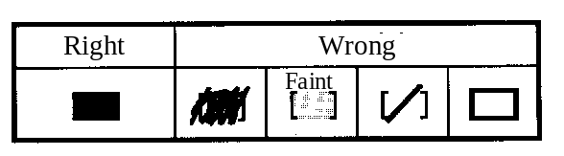
Select one answer (responce option)(A through D)
for each question.
Mark your answer as shown in the following sample
Question.

[Sample Question] In which month is the Spring Information Technology Engineer Examination conducted?

a) 2 | b) 3 | c) 4 | d) 5

Since the correct answer is "C" (4), mark your answer sheet as follows:

[Sample Reply] a) b) c) d)
Do not open the exam booklet until instructed to do so.
Inquiries about the exam questions will not be answered.

Q1. Given the following five pieces of data, how much is the variance?

3, 2, 7, 7, 6

a) 2.1 b) 2.3 c) 2.4 d) 4.4

Ans: Đáp án D. Trung bình của 5 số là 5. Variance của 5 số là (4 + 9 + 4 + 4 + 1)/5 = 4.4

Q2. An integer number from 1 through 100 is generated randomly. What percent is the probability that it is neither a multiple of 3 nor 5?

a) 41 b) 47 c) 53 d) 59
Ans: Đáp án C. Số các số không là hợp số của 3 hoặc 5 = Số các số - Số các hợp số của 3 – Số các hợp số của 5 + Số các hợp số của 3 và 5 = 100 – 33 – 20 + 6 = 53 số

Q3. Which of the following rows represents the same value in binary, octal, decimal, and hexadecimal?

 | Binary | Octal | Decimal | Hexadecimal
a) | 111 | 10 | 8 | 8
b) | 1010 | 12 | 10 | A
c) | 1100100 | 256 | 100 | 64
d) | 11111111 | 377 | 256 | FF

Ans: Đáp án B. A sai vì 111 cơ số 2 là 7 cơ số 10. C sai vì 256 hệ số 8 > 100 hệ số 10. D sai vì FF là 255 chứ không phải là 256.

Q4. If a positive decimal number is shifted 4 bits to the left, by what factor is the original value multiplied? Assume there is no overflow.

a) 0.0625 b) 0.25 c) 4 d) 16

Ans: Đáp án D. Phép dịch chuyển về phía trái n bit tương đương với việc nhân 2^{n}.

Q5. What is the two’s complement of the 8-digit binary number 10110101?

a) 01001010 b) 01001011 c) 10110100 d) 10110110

Ans: Đáp án B. Bù 1 là 01001010, bù 2 là 01001011.

Q6. Which is the value of the expression 0.0011₂ ÷0.001₂? The numbers in the form at x.xx₂ represent binary numbers.

a) 0.00001₂ b) 0.000011₂ c) 0.11₂ d) 1.1₂

Ans: Đáp án D. Dễ thấy 0.0011 > 0.001, kết quả phải lớn hơn 1.
Q7. What is the bit pattern for the decimal number +432 when expressed in packed decimal representation? Assume that the last four bits represent the sign, where “1100” represents + and “1101” represents −.

a) 0000 0001 1011 1100 b) 0001 1011 0000 1100
c) 0100 0011 0010 1100 d) 0100 0011 0010 1101

Ans: Đáp án D. +432 -> 0100 0011 0010 1100 ( 4 3 2 + ).Dấu – là 1101.

Q8. A numeric value is expressed as a 16-bit floating point number in the format given in the figure. Which is the correct representation of the decimal number 0.375? According to the normalized representation used here, the fractional part and the exponent part are adjusted so that the highest order digit of the fractional part may be non-zero.

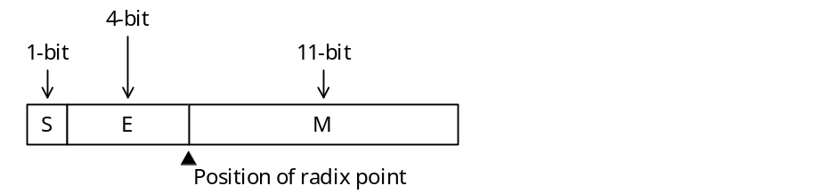
S: Sign of the fractional part (0: positive, 1: negative)
E: Exponent part (base 2 assumed, a negative value is a 2’s complement)
M: Fractional part (represented as an absolute binary value)

a) 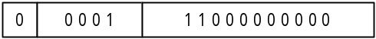

b) 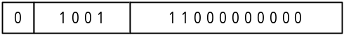

c) 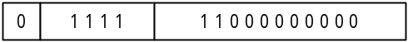

d) 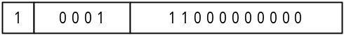

Ans: Đáp án C. 0.375 = 0.011 = 0.11 * 2 ⁻¹ => -1 ~ 1111 bù 2. S = 0, E = 1111, M = 1100000..

Q9. When drawing a circle of area S, by about what percent or less is it necessary to set the relative error of radius r in order to keep the relative error of S at 1% or less?

a) 0.1 b) 0.5 c) 1 d) 2

Ans: Đáp án A. S ~ R * R => khi R sai số x thì S sai số x². Để S sai số 1% hoặc nhỏ hơn thì R sai số 0.1.
Q10. The truth table for the logical operation “x  y” is as follows. Which of the expressions shown under the table is equivalent to this operation?

x | y | x  y
True | True | False
True | False | False
False | True | True
False | False | False

a) x OR (NOT y) b) (NOT x) AND y
c) (NOT x) AND (NOT y) d) (NOT x) OR (NOT y)

Ans: Đáp án . Ở đây chỉ có x = F, y = T thì x * y = T -> đây là phép (NOT x) AND y

Q11. Which logical expression is equivalent to •  • + • B • + A • • + A• B • ? Here, “•” is used to represent a logical product, while “+” is used to represent a logical sum, and 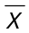 is the negation of X.

a) A b) B c) d)
Ans: Đáp án D . •  • + • B • + A • • + A• B • = • + A • = .

Q12. Given an 8-bit code that includes a parity bit, which of the following bit operations would be used to find the lower order 7 bits other than the highest order parity bit?

a) AND the value with the hexadecimal 0F.
b) OR the value with the hexadecimal 0F.
c) AND the value with the hexadecimal 7F.
d) XOR the value with the hexadecimal FF.

Ans: Đáp án C. Ta cần tìm 7 bit thấp x₁x₂..x₈ -> 0x₂..x₈. Vậy ta cần AND với 01111111 = 7F
Q13. The values at the nodes in the figure satisfy the inequalities A₄ < A₂ < A₆ < A₅ < A₇ < A₁ < A₃. What kind of tree gives this type of relationship?

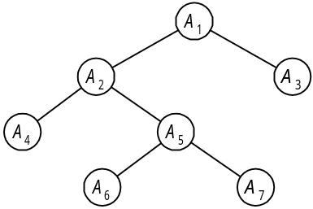

a) Binary search tree b) AVL tree c) B tree d) Heap

Ans: Đáp án A. Đây là cây tìm kiếm nhị phân. Nút gốc có giá trị nhỏ hơn các nút con bên phải và lớn hơn các nút con bên trái.

Q14. The text representation for entering a binary tree is defined as follows. Which is the correct text representation when numbers are assigned to nodes as shown in the figure?

[Text Representation]
(1) Represented as (node number on left subtree or text representation, node number, node number on right subtree or text representation).
(2) x is written when the subtree is empty.

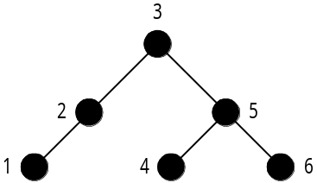

a) ( (1, 2), 3, (4, 5, 6) ) b) ( (1, 2, , 3), x, (4, 5, 6) )
c) ( (1, 2, x), 3, (4, 5, 6) ) d) ( (1, 2, x), 3, (6, 5, 4 ) )

Ans: Đáp án c. Ở đây ta viết theo thứ tự nhánh con trái, nút gốc, nhánh con phải. Do 2 không có nhánh con phải nên x được viết thế vào.
Q15. In this heap, the value of a parent node is less than the values of child nodes. When inserting a node into this heap, an element is added at the very end. If that element is less than the parent node, the parent and child are exchanged with each other. If element 7 is added to the heap at the position marked by the asterisk (*), what element will end up at position A?

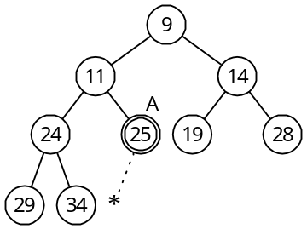

a) 7 b) 11 c) 24 d) 25

Ans: Đáp án B. Khi đó 7 sẽ được thay thế cho 25 rồi thay thế cho 11, thay thế cho 9 và vị trí A sẽ là số 11.

Q16. The flow chart below represents an algorithm for finding the total sum of integers from 1 to N (1 + 2 + ... + N, where N ≥ 1). Which expression should be entered in “a” to complete this algorithm?

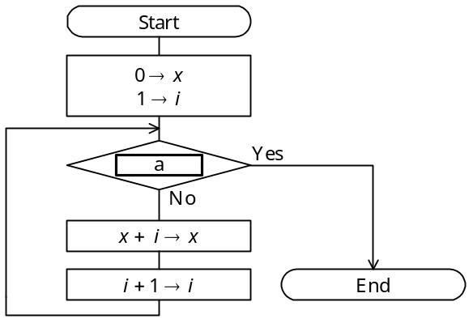

a) i = N b) i < N c) i > N d) x > N
Ans: Đáp án C. Đây là điều kiện kết thúc vòng lặp, với i = N thì x sẽ cộng thiếu N.

Q17. How many data comparisons are made for n pieces of data when using bubble sorting?

a) n b) n log n c) d) 2^{n}

Ans: Đáp án C. Số lượng các phép toán so sánh của thuật toán nổi bọt là n (n – 1) / 2

Q18. In high-speed computing, which of the following methods is used to overlap multiple instructions in execution, such that a single instruction is divided into n independent processing stages so that instructions in each stage may be executed in parallel?

a) out-of-order execution b) cache memory
c) pipeline processing d) branch prediction
Ans: Đáp án C. Trong tính toán tốc độ cao, việc phân nhỏ các công việc thành các trạng thái xử lý độc lập để thực hiện song song là phương pháp đường ống pipeline.

Q19. When specifying an operand address using machine language instruction indexing, what is the effective address for the values given in the table?

Index register value | 10
Instruction address value | 100
Address where instruction is stored | 1000

a) 100 b) 110 c) 1100 d) 1110
Ans: Đáp án C. Đây là phương pháp xác định địa chỉ thanh ghi địa chỉ chỉ số = 1000 + 100 = 1100.

Q20. Given a processor having a basic operating time (clock time) of three nanoseconds, what is the approximate average performance of this processor in MIPS if the number of clock cycles required to execute an instruction and the frequency for that instruction are as shown in the table?

Instruction type | Clock cycles required to execute instruction | Frequency
Operations between registers | 4 | 40%
Operations between memory and  registers | 8 | 50%
Unconditional branches | 10 | 10%

a) 5 b) 30 c) 50 d) 100
Ans: Đáp án C. Ta tính được số xung đồng hồ trung bình cho 1 lệnh là 4*0.4 + 8*0.5 + 10 * 0.1 = 1.6 + 4 + 1 = 6.6 (xung) = 6.6 * 3 = 19.8 (ns). Số lệnh thực hiện trong 1 s = 1/ (19.8 * 10⁻⁹) ~ 50 * 10⁶ (lệnh)

Q21. A processor accesses the main memory in 60 nanoseconds and cache memory in 10 nanoseconds. If there is an 80% probability that data to be accessed exists in cache memory, what is the average memory access time in nanoseconds for that processor?

a) 14 b) 20 c) 50 d) 70

Ans: Đáp án B. Xác suất thực hiện trong bộ nhớ chính 20%. Thời gian thực hiện trung bình = 60 * 20% + 10 * 80% = 20 (ms)
Q22. If the specifications for a dual-sided, double density floppy disk are as shown in the table, what is the data storage capacity of one floppy disk in kilobytes? In this problem, 1 kilobyte is 1,024 bytes.

Number of tracks (single-sided) | 80 tracks
Number of sectors / track | 26 sectors
Data length | 256 bytes / sector

a) 520 b) 1,040 c) 1,064 d) 1,080

Ans: Đáp án B. Số kilobytes có thể lưu trữ của đĩa mềm là 2 * 80 * 26 * 256 / 1024 = 1040 KB

Q23. Assume there is a disk with a rotation rate of 4,200 revolutions per minute and an average seek time of 5 milliseconds. What is the average latency in milliseconds for this disk?

a) 7 b) 10 c) 12 d) 14

Ans: Đáp án C. Tốc độ quay vòng của đĩa là 4200 vòng/phút = 70 vòng/s => Quay 1 vòng hết thời gian là 1/70 s = 14ms -> Thời gian tìm kiếm trung bình = 7ms. Thời gian tìm được trung bình là 7 + 5 = 12 ms.

Q24. What is the correct relationship among the elements a through c, which affect the access time, when reading 100 kilobytes of data stored continuously on a hard disk having the configuration and specifications shown in the figure?

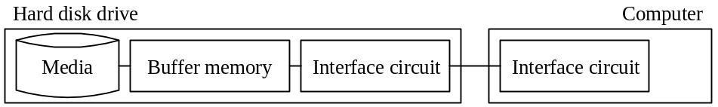

[Hard Disk Drive Specifications]
(1) Rotation rate of medium: 6,000 rpm
(2) Average amount of data per track: 100 KB
(3) Average seek time: 10 ms
(4) Data transfer rate of interface: 5 MB/sec

[Elements Affecting Access Time]
a. Total of seek time and search time for head
b. Data transfer time between media and buffer memory
c. Data transfer time between computer memory and the computer

a) a < b < c b) a < c < b c) b < a < c d) c < b < a

Ans: Đáp án B. Tốc độ quay 6000rpm = 100 rps -> Tốc độ quay 1 vòng = 10ms -> Tốc độ tìm kiếm trung bình = 5ms -> a = 5 + 10 = 15 ms
Thời gian transfer = thời gian đọc dữ liệu trung bình -> mỗi track có 100KB, tốc độ đọc đĩa là 10rps -> 1000 KB/s -> đọc 100 KB dữ liệu cần b = 100/1000 = 1/10 s = 100 ms
Thời gian đọc giữa bộ nhớ và máy tính c = 100KB/5MB = 1/50 (s) = 20 ms

Vậy ta có a < c < b

Q25. Which of the following most accurately describes the performance of a magnetic disk drive?

a) The access time of a magnetic disk drive decreases if the rotation rate is raised or if the seek time is reduced.
b) The storage capacity of such a drive is determined by the storage capacity per track and the number of tracks per cylinder.
c) The data access time includes both the pre-processing time of the processor and the post-processing time after data transfer.
d) The data transfer rate is determined only by the rotation rate of the disk.

Ans: Đáp án A. Tốc độ của một đĩa từ được xét bởi số vòng quay của đĩa từ và thời gian định vị của kim. Như vậy thời gian truy cập của một đĩa từ giảm nếu tốc độ quay tăng lên hoặc thời gian định vị giảm đi. B sai vì nó còn phụ thuộc vào số cylenders. C sai vì thời gian đó không tính cho thời gian truy cập dữ liệu. D sai vì tỉ lệ đó còn phụ thuộc vào số lượng dữ liệu trên một track đĩa từ.

Q26. This media is a 12-cm diameter, 1.2-mm thick disk having a storage capacity of 4.7 GB with a single sided single layer. It is used for storing compressed motion images such as movies in MPEG2 format. What type of medium is this?

a) CD b) DVD c) LD d) MD
Ans: Đáp án B. Đĩa có dung lượng lớn 4.7 GB là đĩa DVD.

Q27. Which of the following most accurately describes the RS-232C standard?

a) It is capable of duplex, bidirectional communications.
b) It has a maximum communications rate of 19,200 bits per second.
c) It allows a daisy chain connection.
d) It is a parallel interface.

Ans: Đáp án A. RS-232C là giao diện truyền 2 chiều nhưng là giao diện nối tiếp, có tốc độ cao tới 56KB/s (loại B, D). Câu C đúng với giao diện SCSI.

Q28. Which of the following most accurately describes a system bus?

a) Widely used in PCs, this standard is for serial transfer of data with a modem or peripheral device.
b) It is a digital signal transfer path shared by multiple devices within the computer.
c) It is a device for converting digital signals to analog signals and analog signals to digital signals.
d) It is a mechanism for transferring data between I/O devices and main memory independently from the CPU.

Ans: Đáp án D. System bus hay Front side bus là đường truyền dữ liệu trong CPU, nó là cơ chế truyền dữ liệu từ I/O với bộ nhớ chính độc lập với CPU.
Q29. Which of the following most accurately describes the I/O interface?

a) ATA/ATAPI-4 (usually called IDE) is an interface that transfers data one bit at a time serially and is used for connecting a modem, mouse, etc.
b) RS-232C is an interface for transferring 8-bit data in parallel and is often used to connect printers.
c) USB has two transfer modes for high speed peripheral devices and low speed peripheral devices and is typically used in high speed mode for printers, scanners, modems, etc.
d) As an infrared communications standard, the Centronics interface is used for data conversions between a notebook computer and a portable information device, transmitting data to a printer, etc.
Ans: Đáp án C. A sai vì ATA/ATAPI-4 được dùng để kết nối ổ cứng. B sai vì RS-232C là giao diện nối tiếp. D sai vì đó là mô tả giao diện IrDA.

Q30. Which of the following is an accurate description concerning printers?

a) It is possible to make carbon copies when using an ink jet printer.
b) It is impossible to print chinese characters (kanji) or illustrations with a dot impact printer.
c) Color printing is impossible with a thermal transfer printer.
d) It is possible to print illustrations and images with a laser printer.

Ans: Đáp án D. Các hình ảnh và hình minh họa có thể in được bởi máy in laser. A sai vì ink jet printer là máy in không va đập nên không có tạo được bản copy. B sai vì máy in dot impact printer hoàn toàn có thể in ra các ký tự Trung Quốc. C sai vì máy in nhiệt có thể tạo máy dựa theo nhiệt độ khác nhau.

Q31. The following figure illustrates the logic circuit for a full adder. In the figure, if 1 is input for x, 0 for y, and 1 for z, then what are the output values for c (carry digit) and s (sum)?

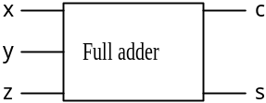

 | c | s
a) | 0 | 0
b) | 0 | 1
c) | 1 | 0
d) | 1 | 1
Ans: Đáp án C. Dễ thấy 1 + 0 + 1 = 10 -> c = 1; s = 0

Q32. What is the correct order of processing and modes for the virtual storage of a paging system when accessing a page that is not in real storage? Assume that there is no page currently available in real storage.

a) Determine the replacement page → page out → page fault → page in
b) Determine the replacement page → page in → page fault → page out
c) Page fault → determine the replacement page → page out → page in
d) Page fault → determine the replacement page → page in → page out
Ans: Đáp án B. Đầu tiên, xác định trang thay thế, đưa trang thay thế vào, lỗi trang, đưa trang đó ra.

Q33. During the execution of a process, it transits through the following states: ready, running and wait. Which is the most appropriate description regarding the state transition of a process?

a) If more than one process which alternately perform CPU processing and I/O processing are executed simultaneously, each process transits only between the running and wait states.
b) The ready state is that state where the process waits for CPU allocation. Generally, there may be more than one ready process, and then a queue is formed.
c) On systems that perform time sharing processing, a process in the ready state transits to the wait state once a certain fixed amount of time passes.
d) On a multi-programming system, there is more than one process in the running state even when there is only one CPU.
Ans: Đáp án B. A sai vì với I/O processing thì process sẽ chuyển từ trạng thái running sang trạng thái wait. D sai vì CPU chỉ chạy một process. C sai vì không có trạng thái chuyển từ ready sang wait.

Q34. Which is the most appropriate definition of the role of task management?

a) The application program creation load is reduced by providing a device-independent means of accessing various types of auxiliary storage devices.
b) Real storage is used effectively by providing a virtual storage space.
c) I/O devices are operated accurately and efficiently by performing I/O device control.
d) The CPU is used effectively by performing multi-programming control.
Ans: Đáp án D. Vai trò của quản lý task là sử dụng CPU một cách hiệu quả trong thực hiện đa chương trình.
Q35. The following table lists the priority of three tasks and the amount of time that each task occupies the CPU and an I/O device when each task is executed independently. How many milliseconds is the CPU idle, starting from the point when all three tasks became ready simultaneously to the point that they have all terminated? Assume there is one CPU, that the I/O for all tasks can be performed in parallel, and that OS overhead is negligible.

Task | Priority | Time required to execute each task independently
A | High | For each task:  CPU 5 milliseconds → I/O 8 milliseconds →  CPU 2 milliseconds
B | Medium
C | Low

a) 3 b) 4 c) 5 d) 6
Ans: Đáp án B. Đầu tiên công việc A sẽ được thực hiện trước trong 5 ms, sau đó được ngắt cho công việc B
A: oooooxxxxxxxxxxoo -> F
B: xxxxxoooooxxxxxxxxoo -> F
C: xxxxxxxxxxoooooxxxxxxxxoo -> F
CPU: AAAAABBBBBCCCCCAAIBBIIICC
Như vậy khoảng thời gian CPU ngắt là 4ms.

Q36. As an operating system repeatedly allocates and frees storage space, many physically separated unused areas appear. What is this phenomenon called?

a) Compaction b) Swapping
c) Fragmentation d) Paging
Ans: Đáp án C. Đây là hiện tượng phân mảnh, các vùng diện tích trống quá nhỏ để có thể dùng.

Q37. Which of the following is a system for loading the necessary segments at run time by dividing the load module into several segments to be executed exclusively?

a) Overlay b) Swapping
c) Dynamic relocation d) Dynamic linking
Ans: Đáp án A. Việc chia module thành các phần khác nhau để thực hiện được gọi là overlay.

Q38. Which of the following is an accurate description of the characteristics of a reentrant program?

a) A reentrant program operates while calling procedures required at run time from an auxiliary storage device. This is an effective technique when there is a limit on the amount of main storage at run time.
b) A reentrant program is one that can call itself from within a procedure.
c) When used by more than one task, a reentrant program can be temporarily used by one task.
d) Even if executed in parallel by more than one task, a reentrant program can return correct results to each separate task.
Ans: Đáp án D. Với chương trình re-entrant, thì nó có thể được thực hiện song song mà vẫn có thể trả về kết quả đúng.

Q39. Which is an accurate description of a compiler?

a) Interprets source programs and executes them.
b) Analyzes syntax and semantics and generates corresponding object code.
c) Edits intermediate code.
d) Stores the load module in main memory.
Ans: Đáp án B. Trình biên dịch phân tích cú pháp và sinh ra đoạn code đối tượng tương ứng. A là interpreter. C là editer. D là loader.

Q40. Which is an appropriate definition of a "data warehouse"?

a) A data warehouse manages data used by information systems. By eliminating the unnecessary duplication of data and by centrally managing data handled separately by department, data resources can be obtained easily because
b) A data warehouse is technology for reducing the volume of data by limiting redundancy of data. This technology is required in image processing because the volume of data handled is excessively large.
c) A data warehouse is a collection of chronologically ordered data that has been compiled depending on the purpose of use. It is useful for decision support, because it allows the utilization and analysis of information from various angles.
d) A data warehouse is software which allows communication among users and the sharing of information among them to make group works efficient.

Ans: Đáp án C. Kho dữ liệu dùng để lưu trữ dữ liệu phụ thuộc vào nội dung sử dụng. Nó được dùng để phân tích và hỗ trợ ra quyết định.
Q41. If the bit pattern "00000 10111 11010" appears in the data field of the transfer frame of an HDLC protocol receiver, what was the original bit pattern sent? Assume that priority of the bit pattern is from left to right and that the space used every 5 bits is meaningless.

a) 00001 01111 1010 (The last 0 of the five consecutive 0's in the receiver's bit pattern is deleted.)
b) 00000 01111 1010 (The 1 in the 6th bit from the left in the receiver's bit pattern is deleted.)
c) 00000 11111 1010 (The 0 in the 7th bit from the left in the receiver's bit pattern is deleted.)
d) 00000 10111 1110 (The 0 in the 13th bit from the left in the receiver's bit pattern is deleted.)

Ans: Đáp án D. Theo phương thức HDLC thì cứ 5 bit người ta sẽ gửi thêm 1 bit 0 để phân biệt với phần control, do đó ta thấy cứ 5 bit 1 liên tiếp thì bit 0 được thêm vào -> 00000 10111 11010 với 0 là chữ số 0 được thêm vào, ta có xâu ban đầu là 00000 10111 1110

Q42. Which is an accurate description regarding the rules for the session layer of the OSI basic reference model?

a) There are protocols for the sequence of data to be transmitted, error detection and recovery process for lost data, and data multiplexing.
b) There are protocols for remote data access, file transfer, etc.
c) There are protocols for error control to do transparent error-free data transfer recovery control procedures, send/receive timing, etc. between adjacent systems.
d) There are protocols for establishing a logical communication path managing interactive actions to support orderly data exchange and exception reporting.
Ans: Đáp án D. Vai trò của session layer là quản lý đối thoại (dialog). A là tầng Data-Link, C là tầng Transport, B là tầng Application.

Q43. The transmitter sees transfer data as a polynomial, and the remainder that results when divided by a predetermined generating polynomial is added to the transfer data as a code used for checking the data. The receiver divides the received data by the same generating polynomial to determine if there has been an error, based on whether or not the polynomial divides into the data. Which error control method is used in this data transfer?

a) Group check b) Cyclic redundancy check
c) Vertical parity check d) Horizontal parity check
Ans: Đáp án B. Việc sử dụng đa thức để tìm lỗi là CRC
Q44. When transferring messages consisting of 90 characters each in start-stop transmission using a 14,400 bits per second line, how many messages can be sent in one minute? Assume that 8-bit, no parity is used for each character and that 1 bit is used for the start signal and stop signal, respectively. Also, assume that line availability is 80%.

a) 12 b) 16 c) 768 d) 960

Ans: Đáp án C. Ta có số bit cần cho 1 kí tự truyền là 10 bit. Số bit cần truyền cho 90 kí tự là 900 bit. Với sử dụng đường truyền là 100% thì 1 s sẽ truyền được 14400/900 = 16 messages. 1 phút truyền được 16 * 60 = 960 (messages). Với khả năng sử dụng đường truyền chỉ là 80% -> số tin nhắn gửi được là 80% * 960 = 768 (messages)

Q45. Which is an accurate statement regarding the characteristics of a bus LAN that uses a CSMA/CD system?

a) No node can communicate until a free token is received.
b) The entire LAN system stops if a failure occurs at the control station.
c) Even if the volume of communication increases, ability to communicate within a fixed period of time is guaranteed.
d) If a node detects the collision of a transmitted signal, the signal is re-sent after waiting a random amount of time.
Ans: Đáp án D. Khi có va chạm, tín hiệu sẽ được truyền lại sau một khoảng thời gian ngẫu nhiên.

Q46. Which piece of hardware is capable of performing protocol conversion between LAN systems whose transport and higher layers are different?

a) Gateway b) Bridge c) Repeater d) Router

Ans: Đáp án A. Phương thức nối các mạng LAN ở tầng transport và các tầng cao hơn là Gateway. Repeater là tầng vật lý. Bridge là tầng DataLink. Router là tầng mạng.
Q47. In the hierarchical file system shown in the figure below, what is the relative pathname that identifies file C2 when the current directory is B1? In the pathname specification, ".." represents the parent directory, and "/" represents the root directory when used at the beginning of the pathname, or is used to delimit directory names and file names when used in the middle. Also, assume that the boxes ( ) represent directories.

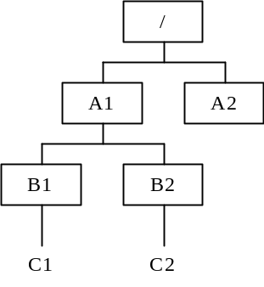

a) | ../A1/B2/C2 |  |  | b) | ../B2/C2
c) | A1/B2/C2 |  |  | d) | /A1/B2/C2

Ans: Đáp án B. Đường dẫn tuyệt đối của C2 là /A1/B2/C2, còn đường dẫn tương đối của C2 từ B1 là ../B2/C2 vì .. sẽ chỉ đến A1 từ B1.

Q48. In the case of relational database operations, what operation creates Table 3 from Tables 1 and 2?

Table 1 |  |  | Table 2 |  |  | Table 3
Number | Product name |  | Number | Ordered by |  | Number | Product name | Ordered by
010 | PC unit |  | 010 | Company A |  | 010 | PC unit | Company A
011 | Display |  | 011 | Company B |  | 011 | Display | Company B
020 | Printer |  | 020 | Company C |  | 020 | Printer | Company C
025 | Keyboard |  | 025 | Company D |  | 025 | Keyboard | Company D
030 | Modem |  | 030 | Company E |  | 030 | Modem | Company E

a) Join b) Projection c) Selection d) Inclusion

Ans: Đáp án A. Đây là phép Join. 2 bảng được kết hợp với nhau để tạo ra 1 bảng khác, loại bỏ các trường giống nhau, ở đây là trường Number.
Q49. In the case of database systems, what method is used to prevent logical inconsistencies when more than one transaction processing program simultaneously updates the same database?

a) Normalization b) Integrity constraint
c) Data-centered design d) Exclusive access control

Ans: Đáp án D. Điều khiển dành riêng được sử dụng khi xử lý truy nhập đồng thời.

Q50. Which operation is used to restore a database using backup files and logs when the storage media on which a database is stored fails (media failure)?

a) Archive b) Commit
c) Check point dump d) Roll forward
Ans: Đáp án D. Phương thức được sử dụng để restore một cơ sở dữ liệu dùng tệp backup và logs khi hệ thống dữ liệu của một database bị lỗi là roll forward.

Q51. In the case of a client-server system, which process is most appropriately performed by the server?

a) Print previews
b) Database updates
c) Checking the format of input data
d) Displaying pull-down menus

Ans: Đáp án B. Việc liên kết với database do server đảm nhiệm, các nhiệm vụ kia đều thực hiện được trên máy client.

Q52. In which system does one computer function normally while the other is in the wait status?

a) Dual system
b) Duplex system
c) Multi-processing system
d) Load share system

Ans: Đáp án B. Hệ thống song công là hệ thống trong đó có một hệ thống dự trữ cho hệ thống kia chạy bình thường.
Q53. Which is the best indicator for evaluating on-line system performance, particularly business processing performance?

a) Execution wait time b) Channel usage
c) Transaction response time d) Paging count
Ans: Đáp án C. Thời gian để đo tính performance của hệ thống on-line là thời gian trả lời transaction. Nó được tính từ thời gian bắt đầu gửi message đi tới thời gian nhận được kết quả trở về.

Q54. One server, three clients, and two printers are connected to a LAN as shown in the figure below. In this system, the server outputs data to a printer based on instructions from a client. Which formula gives the availability of this system? The system is considered normal if one out of three clients is running and if either of the two printers are running. Assume that there is no LAN failure.

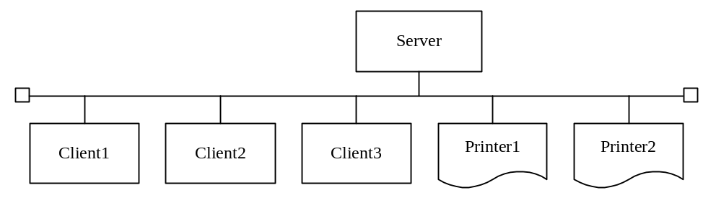

Device | Availability
Server | a
Client 1 | b
Client 2 | b
Client 3 | b
Printer 1 | c
Printer 2 | c

a) ab³ c² b) a (1 − b³ ) (1 − c² )
c) a (1 − b)³ (1 − c)² d) a (1 − (1−b)³ ) (1 − (1 − c)² )

Ans: Đáp án D. Ta có khả năng để hệ thống hoạt động là 1 client hoạt động, 1 printer hoạt động, server hoạt động. Khả năng client hoạt động là 1-(1-b)*(1-b)*(1-b). Khả năng server hoạt động là a. Khả năng printer hoạt động là 1-(1-c)*(1-c). Vậy đáp án là D.
Q55. The curve in the figure below is a graph of frequency of failure. Which reason best explains why the part in the graph indicated by "a" is flat?

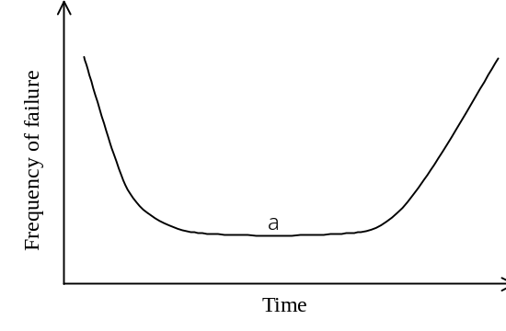

a) Because this is the period where there is a fixed probability of initial failures.
b) Because nearly all initial failures have occurred and this is the period where there is a fixed probability of accidental failure.
c) Because nearly all initial failures and failures due to friction have occurred.
d) Because this is the period where wear-out failure occurs evenly.
Ans: Đáp án B. Đây là thời kỳ ổn định, hầu như các lỗi khởi tạo đã được phát hiện và các lỗi hoạt động xảy ra ngẫu nhiên.

Q56. Which is the most appropriate description of a waterfall model? (A waterfall model is a methodology used in system development.)

a) Applications are designed and implemented in parts and this process is repeated.
b) Since system development proceeds in sequence of process (phase), system development efficiency decreases markedly if an attempt is made to go back.
c) An operable prototype model is developed; the requirement specifications are checked and evaluated at an early stage.
d) Development takes a short period of time due to user participation, development by a small number of people, and the use of development tools.
Ans: Đáp án B. Mô hình waterfall là mô hình thực hiện theo từng phase riêng biệt nối tiếp nhau, hiệu quả của hệ thống giảm nếu có một phần nào đó phải được làm lại.

Q57. The figure below is one part of a DFD at a certain level in a hierarchical DFD. Which is the most appropriate method of describing the DFD of the level immediately below? Assume that the processes in the level immediately below Process n are numbered processes of the form n-1, n-2, etc.

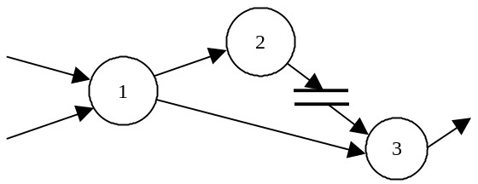

a) 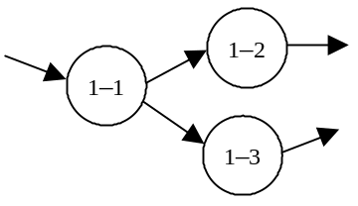 b) 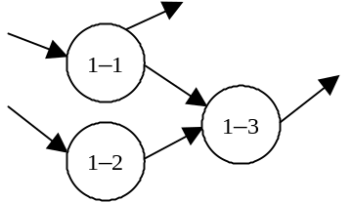

c) 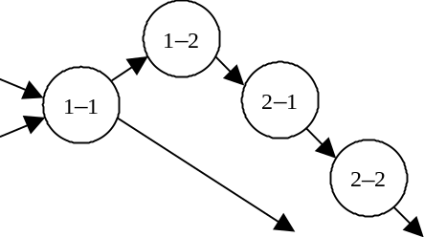 d) 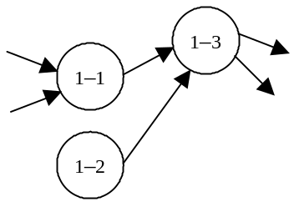
Ans: Đáp án B. Ta thấy process 1 có 2 đầu vào và 2 đầu ra, một vào process 2 và một vào process 3. A loại vì chỉ có 1 đầu vào, D loại vì 1-2 không có đầu vào. C loại vì như vậy không cần thiết phải tách process 2.

Q58. In the case of an object-oriented program, what is it called when data and methods are collected together as one and the details of implementing the objects are hidden from the view of the user?

a) Instance b) Encapsulation c) Clusterization d) Abstraction

Ans: Đáp án B. Trong hướng đối tượng, dữ liệu và phương thức sẽ được đóng gói vào trong đối tượng và ẩn với người dùng.
Q59. Of the module decomposition techniques listed below, which technique decompose a program into modules for input processing functions, conversion functions, and output processing functions according to the flow of data?

a) Source/transform/sink decomposition b) Common function decomposition
c) (JSD) Jackson System Development d) Transaction decomposition
Ans: Đáp án A. Phân hoạch module theo luồng dữ liệu thành ba phần input, conversion và output là phân hoạch STS. Thường được dùng khi phân hoạch bài toán lúc đầu.

Q60. Which is the most appropriate statement regarding the use of the check digit during coding?

a) It is useful in correcting coding errors.
b) It is useful in finding errors in processing from the point of input to the computer to the point of output.
c) It can also be applied to codes that include characters other than numbers.
d) It can detect all coding errors.

Ans: Đáp án B. Check digit là một phương thức để phát hiện lỗi, nó gắn 1 chữ số được tính toán từ dãy các chữ số trong message, thường được dùng để tìm lỗi trong quá trình nhập liệu và xuất dữ liệu.

Q61. When the following ordering data is entered, which check is used to check whether or not a product code exists in the product master file?

Ordering data
Order number  (Text) | Order date  (Text) | Product code  (Text) | Quantity  (Numeric value) | Customer code  (Text)

a) Sequence check b) Collating check
c) Numeric check d) Logical check

Ans: Đáp án D. Kiểm tra logical là kiểm tra xem việc nhập liệu có vi phạm logic ràng buộc trong database không. Sequence check là kiểm tra trình tự, Numeric check là kiểm tra xem đó có phải số không, Collating check là kiểm tra đối chiếu.
Q62. Which is the most appropriate description of the white box test? (The white box test is a test method.)

a) Modules are successively joined from the bottom module to the top module.
b) Modules are successively joined from the top module to the bottom module.
c) The test is performed while paying attention to the internal structure of modules.
d) The test checks whether or not functions operate according to the specification without consideration of the internal structure of modules.

Ans: Đáp án C. White box test là phương thức test tới cấu trúc bên trong của module. Câu A là test từ trên xuống, câu B là test từ dưới lên, câu D là black box test.

Q63. Which is the most appropriate description of an operation testing system and procedures?

a) The operations test is conducted as a pre-process of the system test.
b) The development department sets a test case and the user department performs a test according to the test case.
c) The development department leads the test as its final responsibility.
d) The user department takes the initiative, and the test is performed under the same conditions as during the actual production run.
Ans: Đáp án D. Kiểm thử vận hành là kiểm thử trên môi trường với các điều kiện giống với môi trường thực mà sản phẩm sẽ chạy. A sai vì nó là quá trình kiểm thử cuối cùng, B sai vì đó là kiểm thử tích hợp, C sai vì đó kiểm thử hệ thống.

Q64. Which is the most appropriate description of the progress of a walkthrough?

a) Mainly a solution scheme is studied.
b) Performed under the direction of a development manager, and the developers do not participate.
c) A summarized version of materials in question is used for the walkthrough.
d) It concentrates on finding problems.

Ans: Đáp án A. Walkthrough là giải trình do người thiết kế ra sản phẩm và những người ngang quyền nhằm phát hiện lỗi sớm nhất có thể được, chủ yếu là xem xét một giải pháp.

Q65. Which is the correct pair of values for variables A and B after executing the program in the figure below, consisting of the main program "Main" and the sub-program "SubX"? The parts of the program given inside square brackets describe the code that appears in that location.

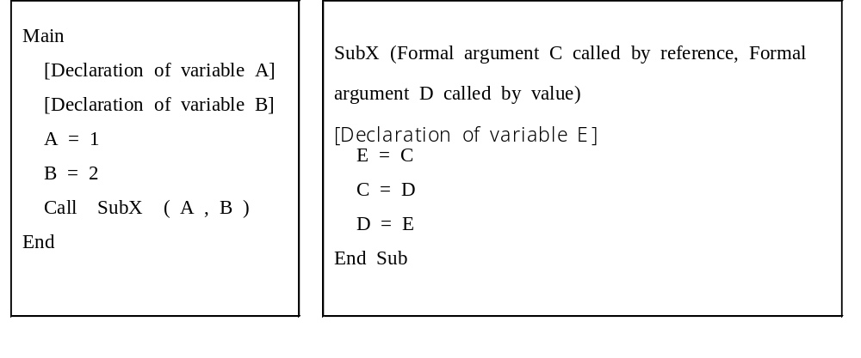

 | A | B
a) | 1 | 1
b) | 1 | 2
c) | 2 | 1
d) | 2 | 2

Ans: Đáp án D. Do tham số C là tham chiếu, tham số D là tham trị nên B sẽ không bị thay đổi giá trị khi gọi hàm SubX(A,B), còn A bị thay đổi và giá trị nó nhận giống B. A=2, B=2.

Q66. Of the following examples of errors, which is detected by the linkage editor?

a) The pairing of parentheses or of braces indicating groups or blocks was incorrect.
b) Declarations of variable names used locally by the program and their attributes were forgotten.
c) Program logic was incorrect.
d) The name of a subroutine to be called was incorrect.

Ans: Đáp án D. Tên của các tên hàm được gọi không đúng. A là lỗi cú pháp bị phát hiện bởi compiler, B cũng là lỗi logic, nó được phát hiện trong bước execution chứ không phải loader.
Q67. Which is the most appropriate statement regarding the characteristics of a Gantt chart used in progress management?

a) It allows one to clearly understand the effect on one procedure if another is delayed.
b) It clearly shows the sequential relationship of procedures.
c) It defines the critical path--a point in progress management--to be clearly defined.
d) It allows plans and actual results regarding the daily schedule to be compared.
Ans: Đáp án D. Biểu đồ Gantt so sánh kết quả hoạt động của quá trình phát triển so với plan ban đầu. Nó không chỉ rõ mối quan hệ giữa các quá trình, cũng như chỉ ra đường găng(critical path), được chỉ ra bởi sơ đồ PERT.

Q68. Which of the following is the most appropriate to receive approval for when the high-level (external) design of a system is complete?

a) Screen layout b) System development plan
c) Process methods d) Flow chart
Ans: Đáp án D.Khi high-level design của một hệ thống được hoàn thành thì nó sẽ tạo ra được Flow chart. A là thiết kế chi tiết. B là lập kế hoạch. C là phần thực hiện.

Q69. At how many thousands of yen is the break-even point when the items calculated from a profit and loss statement are as given in the table below?

Unit: Thousands of yen
Item | Amount
Total sales | 1,000
Variable costs | 800
Fixed costs | 100
Profit | 100

a) 500 b) 700 c) 800 d) 900

Comment: ‘yen’ should be replaced by the currency unit used in your country.

Ans: Đáp án A. Thu nhập hòa vốn (break-even point) = chi phí cố định / (1 - tỷ số chi phí biến thiên). Tỷ số chi phí biến thiên = 800 / 1000 = 0.8. Thu nhập hòa vốn = 100/ (1 – 0.8) = 500
Q70. Approximately how many thousands of yen is the depreciation for three years if depreciation is performed using the fixed rate method for a device as shown in the table below?

Acquisition cost (thousands of yen) | 1,000
Life expectancy (years) | 5
Residual value (%) | 10
Depreciation rate | 0.369

a) 132 b) 147 c) 180 d) 332

Comment: The same as written to Q69.
Ans: Đáp án B. Ta có năm thứ nhất giá trị sụt giá còn 1000 – 1000 * 0.369 = 631
Ta có năm thứ hai giá trị còn 631 – 631 * 0.369 = 398
Ta có năm thứ ba giá trị sụt giảm là : 398 * 0.369 = 147

Q71. In the case of the tasks shown in the arrow diagram in the figure below, results of a detailed task review found that the time to complete Task D could be shortened by three days. By how many days was the time required to complete all tasks reduced? Assume that the dotted arrow is a dummy task.

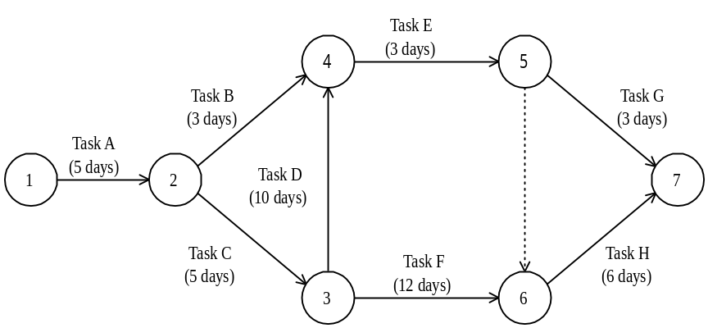

a) 0 b) 1 c) 2 d) 3

Ans: Đáp án A. Công việc D có thể rút ngắn ba ngày còn 7 ngày, khi đó đường găng vẫn là 1 -> 2 -> 3 -> 6 -> 7. Như vậy tổng thời gian hoàn thành toàn bộ các công việc không giảm = 28 days.
Q72. Which is the most appropriate description of a diagram used in product quality control?

a) A scatter diagram is useful in coming to know the fluctuations in single variable data and finding the average value and standard deviation.
b) An affinity diagram is used to gather and organize confusing problem points and inconsistent opinions, ideas, etc.
c) A cause and effect diagram (fish bone diagram) is useful in representing the relationships between two or more variables.
d) A diagrammatic representation used to contrast causes and results, a frequency distribution diagram is used to investigate the cause of failure.

Ans: Đáp án A. C sai vì cause and effect diagram miêu tả mối quan hệ nguyên nhân và kết quả, D sai vì diagrammatic miêu tả hành vi của con người, affinity diagram thì được sử dụng trong quản lý để lập kế hoạch.

Q73. Which is the most appropriate description of a periodic ordering system used in inventory management?

a) This system is suited for managing A rank goods under ABC analysis.
b) Economical amounts are ordered to minimize the costs of operation.
c) This system is used by the double shelves method.
d) This is also called the ordering point system.

Ans: Đáp án A. Đây là phương pháp quản lý thích hợp cho các hàng hóa lớp A. B sai vì số lượng đặt hàng phải đảm bảo kho chứ không phải tối thiểu chi phí hoạt động. C sai vì phương thức này không phải là phương thức double shelves. D sai vì đó là phương thức đặt hàng số lượng cố định.

Q74. The following figure is a conceptual diagram of a public key cryptosystem. Which is the correct combination to be inserted in a and b?

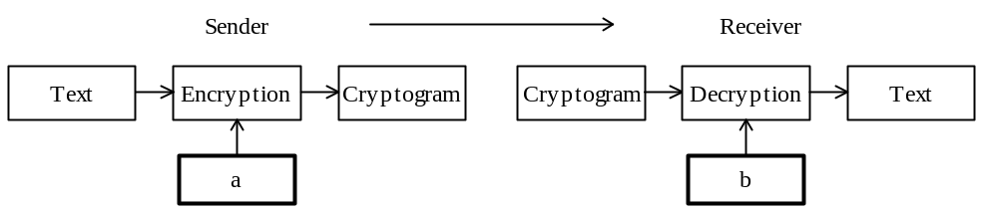

 | a | b
a) | Public key on receiver's side | Private key on receiver's side
b) | Private key on receiver's side | Public key on receiver's side
c) | Public key on sender's side | Private key on receiver's side
d) | Private key on sender's side | Public key on receiver's side

Ans: Đáp án A. Về phương pháp mã hóa này thì sender sẽ dùng khóa public của người nhận để mã hóa và người nhận sẽ sử dụng khóa riêng của mình để giải mã.

Q75. Which is the most appropriate and effective management method for preventing the tampering and destruction of data by the illegal execution of a utility program?

a) Keeping a system log
b) Comparing the source program with the execution program
c) Backing up data
d) Setting file access privileges

Ans: Đáp án D. Việc tránh data bị phá hủy bởi một chương trình không hợp lệ, hiệu quả nhất là sao lưu dữ liệu. A sai vì tệp log chỉ ghi lại chứ không tránh khỏi việc phá hủy dữ liệu, B rõ ràng khó thực hiện được bởi vì như vậy phải sử dụng source code, không bảo mật, C sai vì nó không ngăn chặn được việc dữ liệu bị xóa khi bị sử dụng trái phép, nó chỉ cho phép dữ liệu được roll-back khi xảy ra sự cố.

Q76. Which of the following costs is included in the loss caused by destruction of data and loss of system availability?

a) System re-development costs and database porting costs due to changes in the business style.
b) Costs associated with studying the feasibility of system development.
c) Costs associated with alternative procedures until the system is recovered.
d) Costs of transition to the new system.

Ans: Đáp án C. Việc thay đổi kiến trúc data sẽ làm cho thay đổi một số thủ tục liên quan.
Q77. Which is the most appropriate statement related to copyrights?

a) A copyright is not secured unless registered with the competent office.
b) The competent office is the Patent Office.
c) The term of validity of a copyright is 20 years.
d) A copyright comes into existence at the point in time a work is created.
Ans: Đáp án D. A sai vì copyright không cần thiết phải đăng ký với cơ quan cấp bằng sáng chế, theo công ước Berne. C sai vì thời gian hợp lệ của nó tính từ thời điểm tác giả mất cộng thêm 50-70 năm. B sai vì cơ quan đó cấp bằng sáng chế cho phát minh ưu việt, không phải copyright.

Q78. Which is the most appropriate statement related to preventing unfair competition act?

a) If only false information which is harmful to the business reputation of a competing company is spread, the demand for the suspension of such activities or the demand for its compensations cannot be made.
b) Even items of information made public at conferences and through descriptions in brochures given to customers during meetings are protected as corporate trade secrets.
c) Demand for suspension or demand for damage compensation can he made against imitations, including dead copies of another person's product design, and illegal usage of a trade mark which may be mistaken or confused as showing a product or a marketing activity of another person.
d) Even if a logo or symbol is generally widely recognized as representing a particular product, unregistered trademarks and designs are not protected.
Ans: ??? Đáp án A. Các câu B, C, D đều liên quan đến bản quyền.

Q79. Which of the following is the most appropriate description of the information defined by the product quality assurance standard ISO 9001?

a) It is a product quality assurance model for final inspection and testing.
b) It is a product quality assurance model for manufacturing, installation, and incidental service.
c) It is a product quality assurance model for design, development, manufacturing, installation, and incidental service.
d) It is a guideline for product quality management and product quality system elements.

Ans: Đáp án C.
Q80. Which of the following is an appropriate description for how graphs are used in presentations?

a) Z charts are used to show sales performance in a fixed period and results of analysis of trends in business performance by an enterprise.
b) Circular graphs are used to show the actual state of progress against work schedules.
c) Broken line graphs are used to show the relative merits of product features based on several items that have been evaluated.
d) A scatter diagram is used to show the market share of each company for a product.

Ans: ???Đáp án A. Đáp án B sai vì đó là biểu đồ Grantt. Đáp án C sai vì broken chart là dạng đồ thị XY trong đó các đồ thị chỉ vẽ trên một biến đo lường. Đáp án D sai vì scatter diagram không phải dùng để chỉ việc phân chia thị trường của mỗi công ty cho cùng một sản phẩm, đó là biểu đồ circular.

